Week 4 day 1 notes
Queues
2 systems
Overburdening the license system by sending too many requests
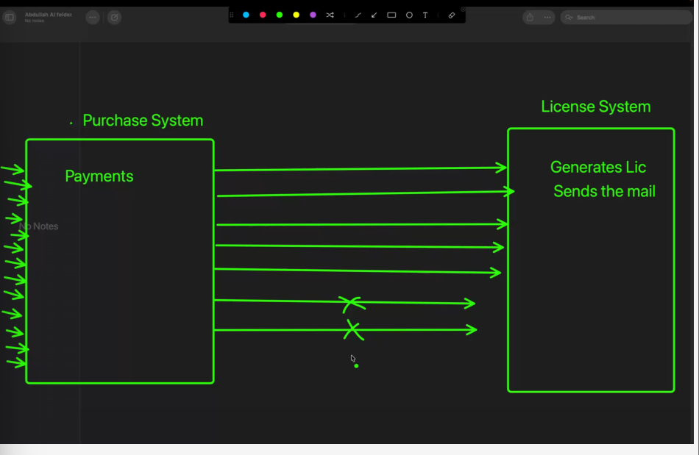
Directly coupled systems- a change in one system will break the other system
Need to bring a new player here-queues
Queues advanatge-improve performance, decoupling of systems/architecture, instead of one license system we can attach more license systems (helps to scale the architecture), backbone of modern architectures
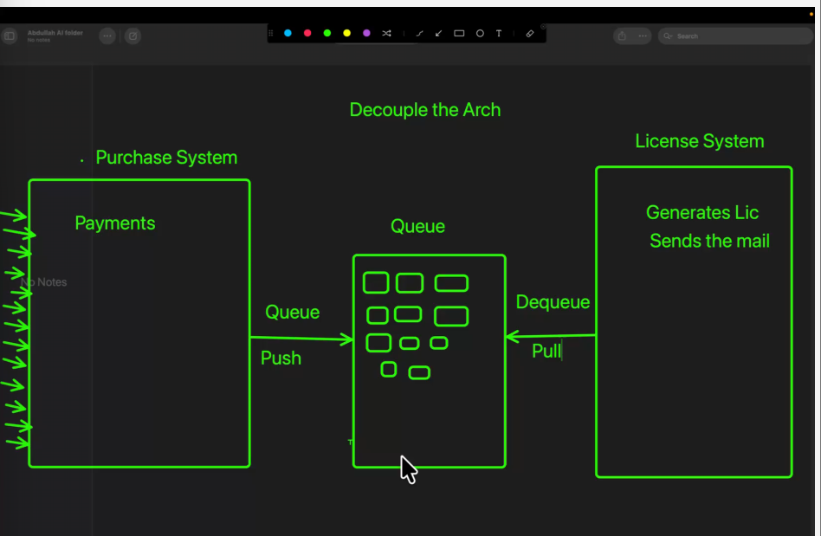
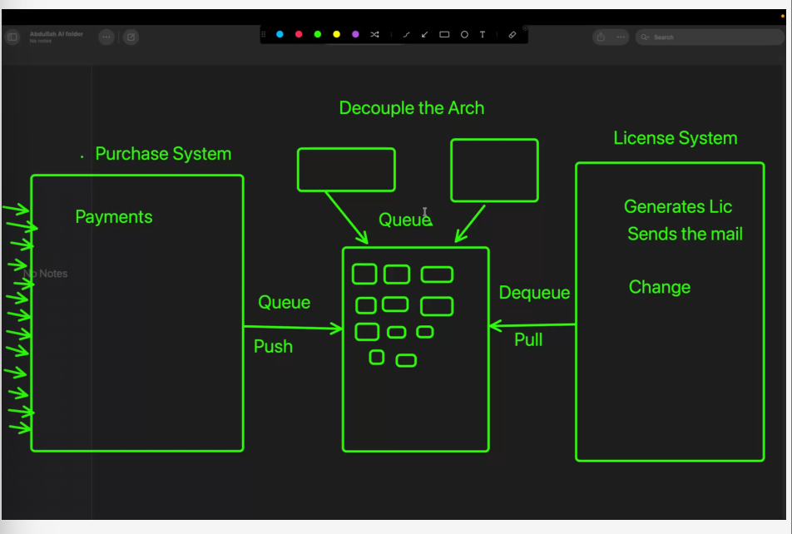
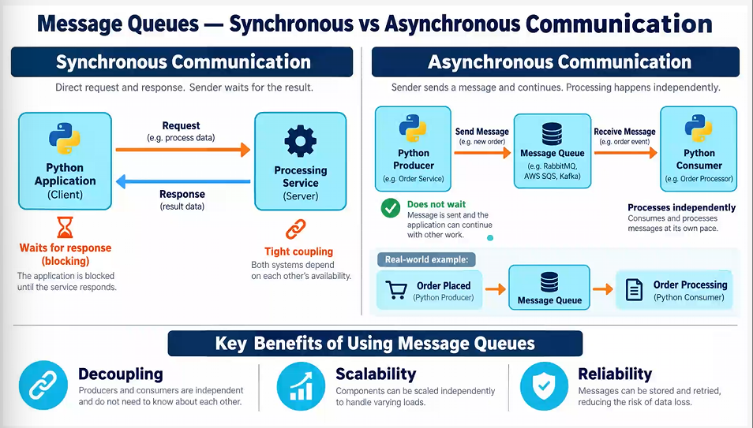
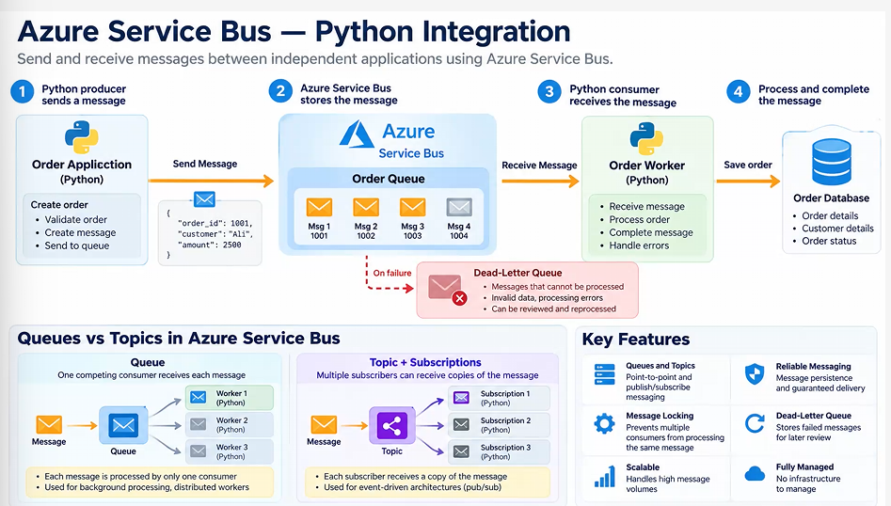
Advanced queuing-Made partitions inside the queue(each partition is called a topic)
Each topic- hub analogy(delhi, Bangalore etc)
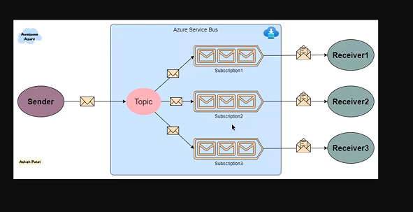
Subscription 1 -for bangalore and so one etc for all subscriptions
Eg: branching when we order something according to cities
Messages are processed based on region and distributed based on topic
Pyspark tutorial
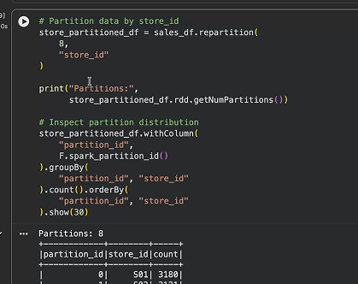
Partitioned based on store id
Higher the complexity of the system, higher the number of topics
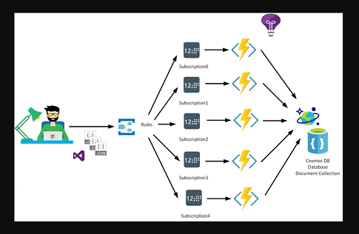
Topics are sorted within the system
RabbitMQ-non azure perspective, we work with “exchange” and “queue”
